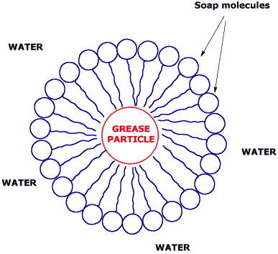**Color Changing Milk**

**Purpose:** To investigate the properties of the polarity of milk and soap as well as test this effect on different types of milk.

**Concept:** In this lab, you will apply the effects of soap onto milk.

Milk is actually a mixture of vitamins, minerals, proteins, and particles

of fat suspended in a solution. Soap is actually a substance that has a polar end and a nonpolar end. When soap is used to clean up grease from dirty plates or your hands, the nonpolar (hydrophobic) end surround the nonpolar grease particle with the polar ends of the molecule sticking out. Scientists call this a micelle (seen in the picture above). This allows for the grease/micelle particle to be dissolved in water and washed away easily. This property will be in effect during the lab today.

**Variables:** Different types of milk (skim, 1%, 2%, whole)

**Materials:**

Petri Dish Q-tips different milks dish soap

**Procedure:**

1. Make a table/area on the back of this sheet to record observations for the different types of milk.
2. Acquire the materials needed for the lab.
3. Measure out 30-40 mL of the first type of milk you are going to use and add it to your Petri dish.
4. Add a few drops of food coloring close to the middle of the Petri Dish.
5. Take a Q-tip, dip it in soap, and make sure that there is no soap dripping off of the Q-tip.
6. Touch the Q-tip to the middle of the Petri dish & observe.
7. Record your observations on the back of this sheet. Be very specific with your observations so that you can compare the differences between the different types of milk.
8. You may dump the milk down the drain.
9. Repeat this process for the other types of milks being used in this experiment.

**Questions**

1. Is water polar or non polar?
2. What property allows for this process to happen?
3. What do you think is causing the milk/dye to move?